HELPSHEET FOR THE ENGLISH WORK
- Go to the website https://www.thenational.academy/
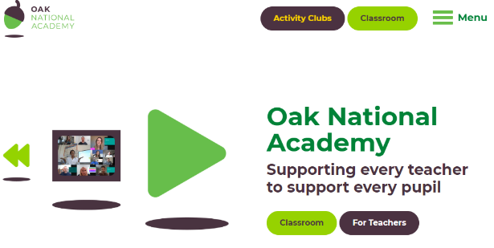

- Click onto Classroom

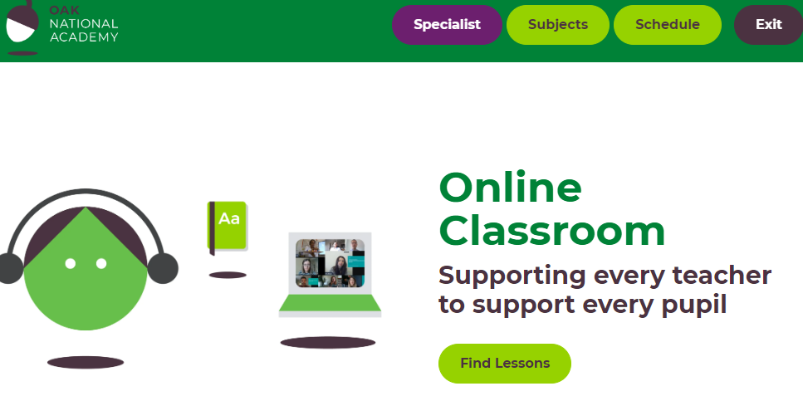
- Click onto Subjects
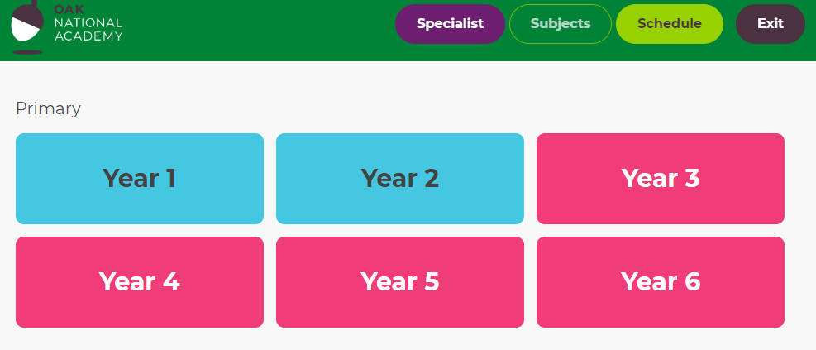
- Click onto Year 4

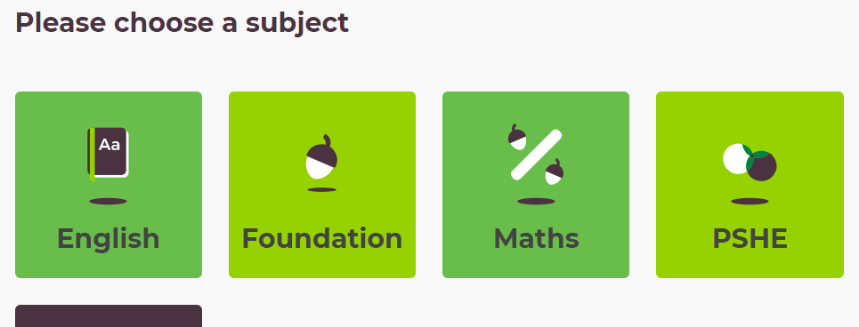
- Click onto English.
