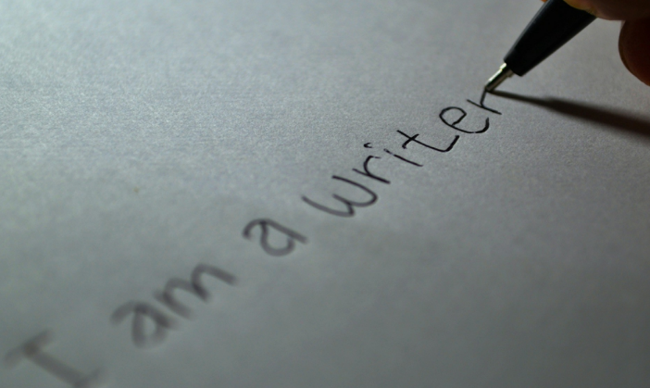

Writing
- Learn to spell the Year 2 common exception words. (see front of homework books)
- Learn the possessive apostrophe (for example, the girl’s book)
- Start using some of the diagonal and horizontal strokes needed to join letters.
- Use full stops, capital letters, exclamation marks, question marks, commas for lists and apostrophes for contracted forms. (would not = wouldn’t, she will = she’ll etc).
- Use expanded noun phrases (more than one adjective) to describe (for example, the beautiful, blue butterfly).
- Use the present and past tenses correctly and consistently.
- Use subordinating (using when, if, that, or because) and co-ordinating (using or, and, or but) conjunctions to join short sentences.

Reading
- Read most words quickly and accurately.
- Re-read books to build up fluency and confidence in reading.
- Listen to, discuss and express views about a wide range of books.
- Discuss the sequence of events in books.
- Discuss and clarify the meanings of new words.
- Discuss favourite words and phrases.
- Check that the text makes sense to them as they read and correct inaccurate reading.
- Make inferences on the basis of what is being said and done.
- Answer and ask questions.
- Predict what might happen on the basis of what has been read so far.

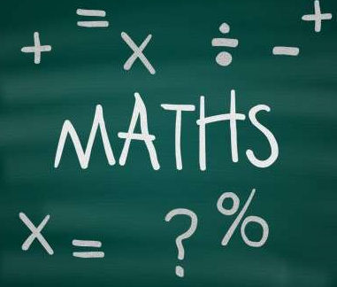
Mathematics
- Compare and order numbers from 0 up to 100.
- Read and write numbers to at least 100 in numerals and in words.
- Add and subtract numbers using simple methods and mental calculations.
- Add and subtract a two-digit number and ones, a two-digit number and tens, two two-digit numbers and add three one-digit numbers.
- Recall and use multiplication and division facts for the 2, 5 and 10 times tables.
- Recognise, find, name and write fractions of a length, shape, set of objects or quantity.
- Write simple fractions. (for example, ½ of 6 = 3)
- Find different combinations of coins that equal the same amounts of money.
- Tell and write the time to five minutes and draw the hands on a clock face to show these times.
- Identify and describe the properties of 2-D shapes, including the number of sides and line symmetry in a vertical line.
- Identify and describe the properties of 3-D shapes, including the number of edges, vertices and faces.

End of Year Expectations
For Year 2 at Brownlow Fold

This booklet provides information for parents and carers on the end of year expectations for children in our school. The staff have identified these expectations as being the minimum requirements your child must meet in order to ensure continued progress throughout the following year.

All the objectives will be worked on throughout the year and will be the focus of direct teaching. Any extra support you can provide in helping your children to achieve these objectives is greatly valued.

If you have any queries regarding the content of this booklet or want support in knowing how best to help your child, please talk to your child’s teacher.

