Online Reading books and Comprehension Questions

- Please visit the following website https://www.activelearnprimary.co.uk
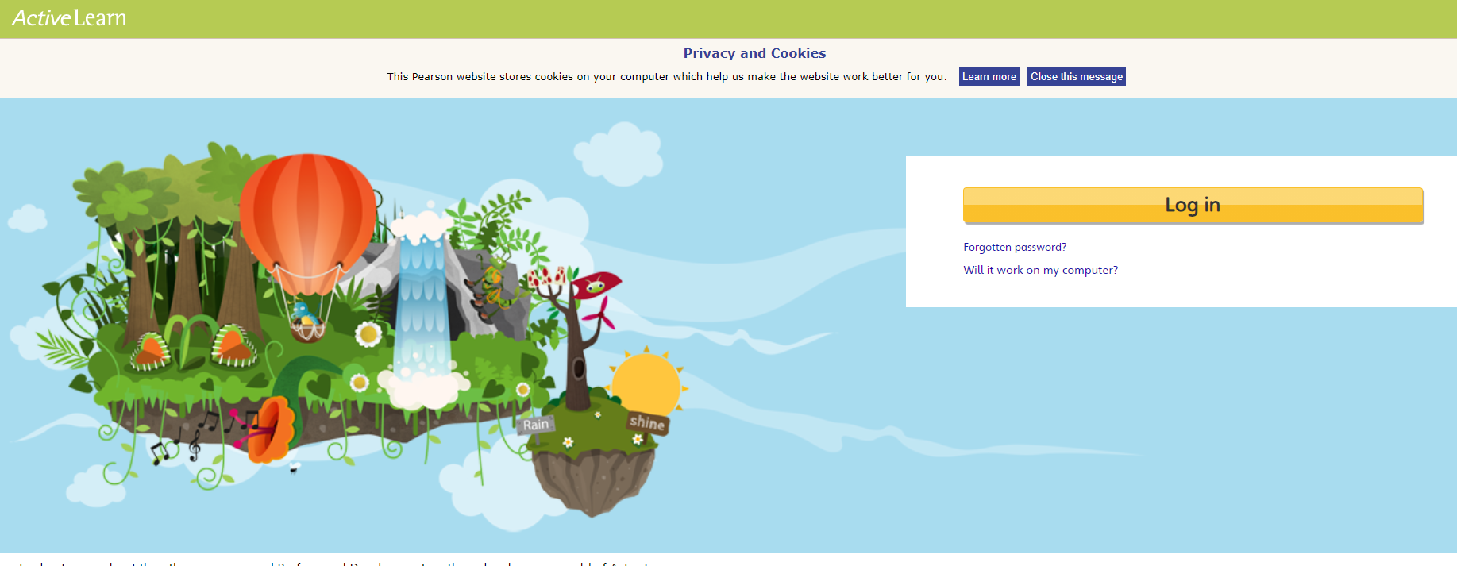
- Type in your Log in details

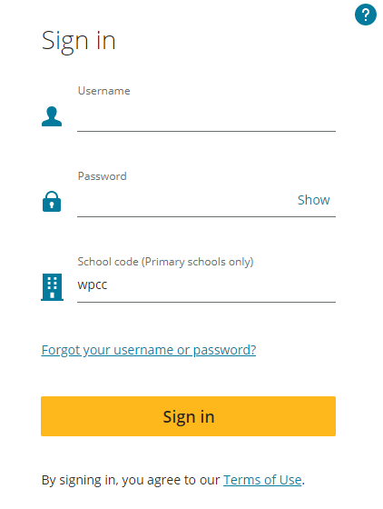
- Your Teachers have set you some books to read at home. Enjoy reading them.
- On some pages in the book you will see an alien picture, click on it to answer questions about the text.
- Your teacher will check your reading progress as they can look online at the books you have read and the questions you have answered.

